**Name: raksha**

**Date: 18/7/25**

**Batch11**

**Terraform class 2 tasks**

**Question 2**

**2. create 3 .tf files with singles resources inside.**

File1.tf

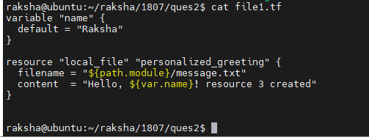

**File2.tf**

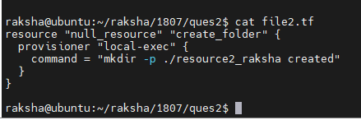

**File3.tf**

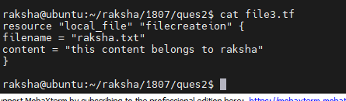

**Terraform init**

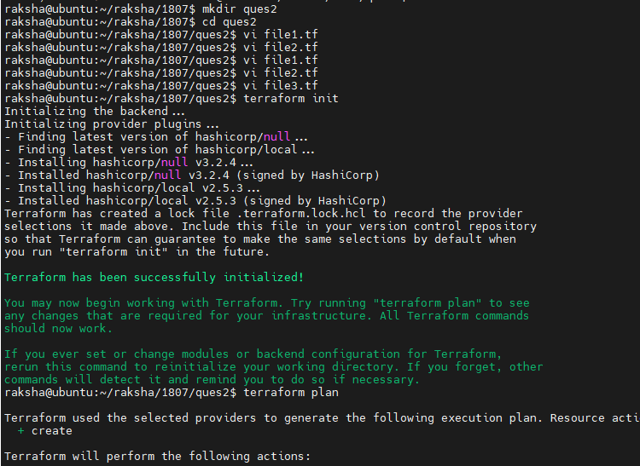

**Terraform plan**

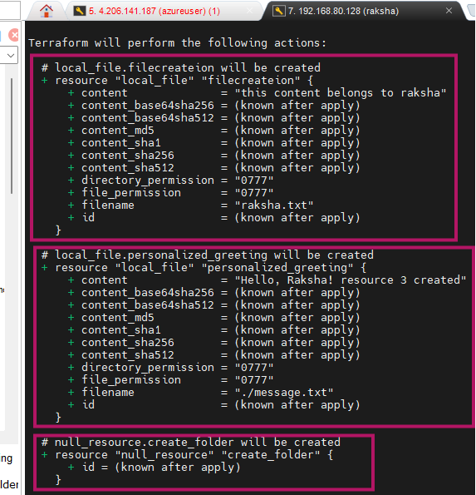

**Terraform apply**

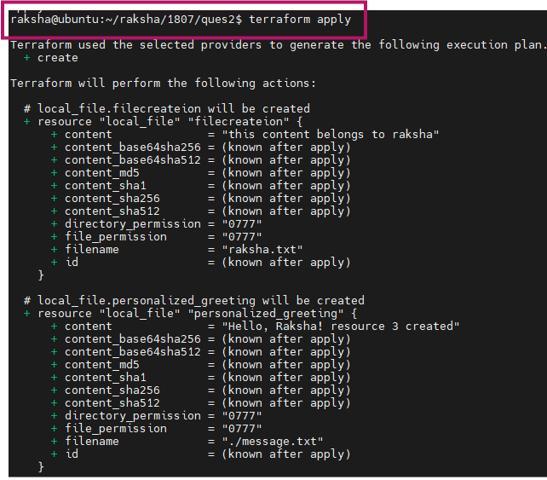

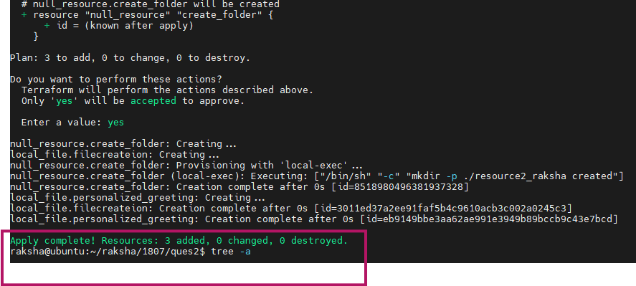

**Tree and tree -a command used to get detailed file creation path**

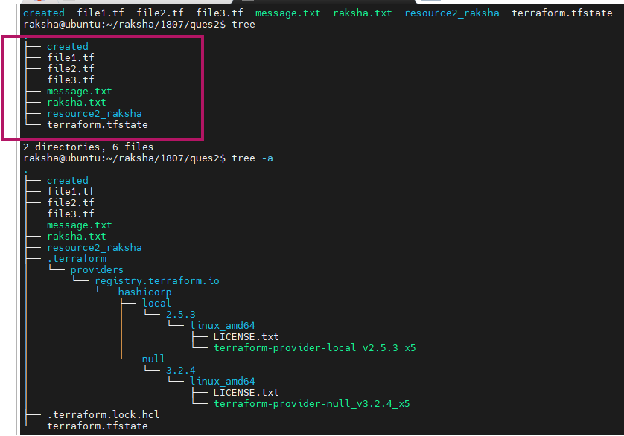

**In below pic shows message.txt , raksha.txt files contents and created one directory name called resource_raksha**

